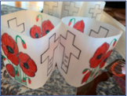

ANZAC DAY 2020
This year we are called as a Nation to keep the ANZAC spirit alive more than ever. The inability to gather as a group and acknowledge the sacrifice and service of our past and present Defence personnel just means we need to get creative. As a school community, Our Lady of Dolours has always celebrated ANZAC Day with incredible pride and reverence.
Below is a selection of activities you may wish to engage in as a family.
Bake ANZAC biscuits
Create footpath ‘chalk art’
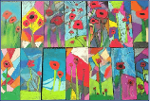
Create your own family ANZAC Day wreath and leave it on your doorstep
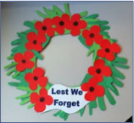
Write a prayer for an unknown soldier and email a photo to Mrs Wilson. I will make sure it reaches our Defence personnel.
Build your own ANZAC Day memorial out of Lego and send a photo to Mrs Wilson.
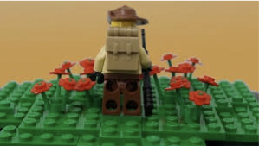
Play a game of two-up (played by the soldiers during WW1)
Poppy Craft – use red paper plates, patty tins or whatever you like!
