Tashi

Activity 2: Write a newspaper report for ‘The Village Newspaper’ describing how Tashi saved the village from the dragon.

We are learning to
- select a text structure (a newspaper report) appropriate for the writing purpose
- sequence content according to that text structure, introducing the topic, and grouping related information in well-sequenced paragraphs with a concluding statement
- use vocabulary, including technical vocabulary, appropriate to the purpose and context
- use paragraphs to present and sequence a text
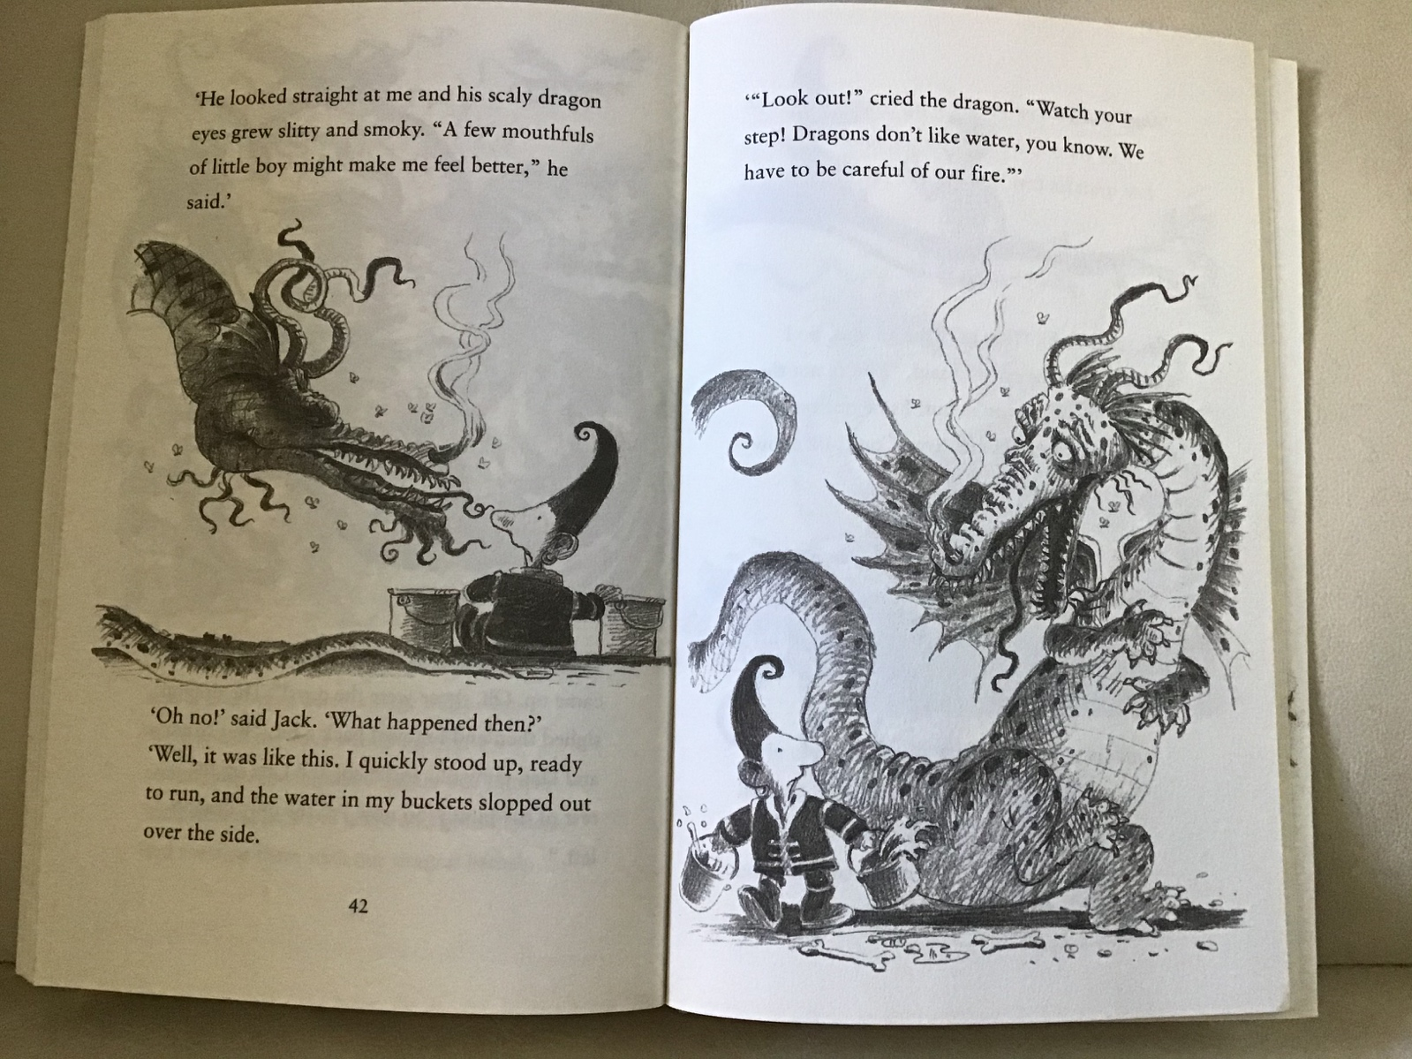
Activity 2: Write a newspaper report for ‘The Village Newspaper’ describing how Tashi saved the village from the dragon.

Planning your Newspaper Report

Headline:
This is a short, attention-getting statement.

The headline often contains:
a pun: a play on words that is funny (or meant to be funny) :-

Dragon stops smoking!!

or

alliteration: the same letter or sound is repeated at the beginning of consecutive words :-

Tiny Tashi Terrorises Dopey Dragon!

Byline:
This tells who wrote the report (your name!!!!)

Introduction: (paragraph 1)
Introduces the topic, this tells what happened, where it happened, when it happened
and who was involved.

Body: (paragraphs 2 and 3)
This develops and expands the information in the introduction;
it tells the reader a lot more of the details about what led up to the event happening, why the event happened.

It should include some interviews with any of the characters involved, where they tell the reader their side of the story. What might Tashi have said? What might the dragon have said?
It should also include interviews with any ‘eye-witnesses’, people who saw the event happening and want to get their name in the newspaper! Who were these people? Why were they there? What did they see? What did they hear? How did they feel about the event?

Photograph(s):
These show the reader what happened and contain captions. In your first ‘photo’ draw the event at its most exciting or most dramatic part.
In a second ‘photo’ draw the event just after it has happened.
This is sometimes called ‘the aftermath’.

A caption is a short sentence written underneath the photo, explaining who is shown in the photo and what is happening.

Conclusion: (paragraph 4)
This summarises the story and gives the reader some suggestions about what might happen next.

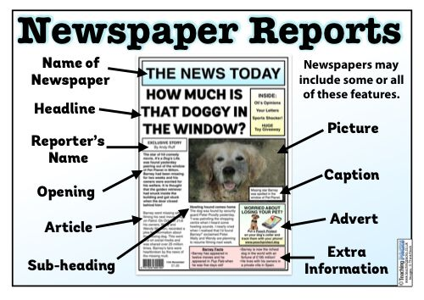

Use the examples below to guide you.
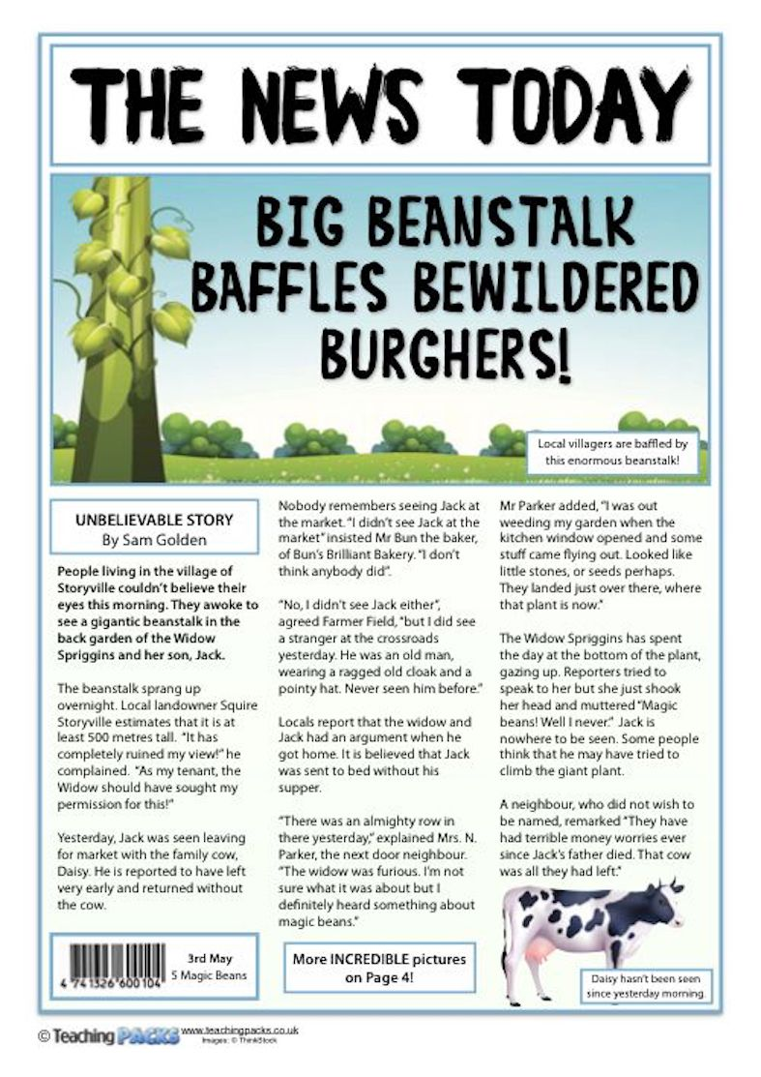
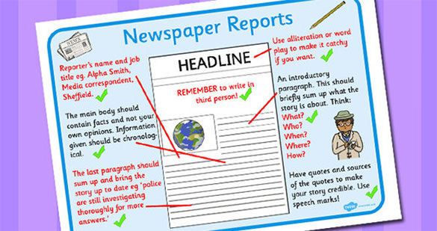
I’ve given you a fairly basic template below, but you might want to design your own newspaper front page instead.

The Village Newspaper

TERRIFIC TASHI SAVES VILLAGE FROM DANGEROUS DRAGON
_______________________________________________________________________________________________________________________________________________________________________________________________________________________________________________________________________________________________________________________________________________________________________________________________________________________________________________________________________________________________________
___________________
___________________
___________________
___________________
___________________
___________________
___________________
______________________________
________________________________________________________________________________________________________________________________________________________________________________________________________________
_________________
_________________
_________________
_________________
_________________
_________________
_________________
_________________
_________________
_________________

_____________________________
________________________________________________________________________________________________________________________________________________________________________________________________________________________________________________________________________________________________________________________________________________________________________________________________________________________________________________________________________________________________________________________________________

