Activity 5, Creative Writing

Write your very own ‘Tashi and the Stolen Bus’ adventure story…..

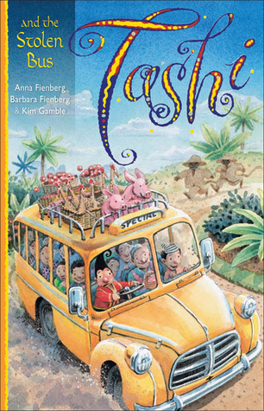

So………….. what if this photo was the ‘stimulus’ for this year’s NAPLAN writing activity?
(It’s not, NAPLAN”s cancelled this year - - happy dance).
We’ve practised lots of these pieces of writing at school, so let’s use our skills to create a wonderful, imaginative adventure.

Take some time to plan your story first:

- What could be the setting for your story?

- Which characters are going to join Tashi in the story? Are you going to use some characters you’ve read about or are you going to create some of your own?

Do you remember our ‘story mountains’?

- What fairly normal or ordinary activity might Tashi or Jack be doing at the beginning?

- What extraordinary event might happen next?

- What extraordinary characters might appear, like dragons or Genies?

- What might the main character (Tashi) do to solve the problem?

- Where might everyone be and how might everyone feel at the end of the story?

You could choose to handwrite this or you could type it on a Word document. You could even illustrate it in a similar way to Kim Gamble’s illustrations.

