Biography of an author: Mem Fox
Mem Fox is one of Australia’s most famous authors. She was born in Melbourne, grew up in Africa, went to drama school in England, and came back to Australia in 1970, aged 22.
In 1983 Mem became Australia’s best-selling writer. Possum Magic, her first book, is still available in hardback after 34 years and has become an absolute favourite for millions of Australian families. She has written over 40 children’s books and several non-fiction books for adults. Her books have been translated into twenty-one languages, and many of them have been international best sellers.
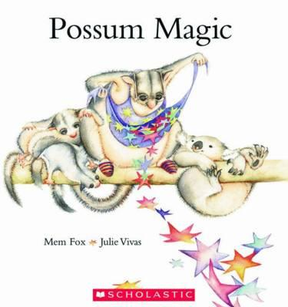
Apart from Possum Magic, Mem’s books also include Wilfrid Gordon Macdonald Partridge, Time for Bed and Where is the Green Sheep? These are all fantastic stories to read to younger readers because they are filled with great language and interesting characters.
Mem has been a University lecturer, teaching teachers for 24 years. She has received many honours and awards.
Her latest book, ‘I’m Australian Too’, is all about her love for Australia. She hopes it will spark discussions about Australian-ness and create an awareness of Australian immigration over the centuries.
You can find most of Mem’s books in our Library in the Junior Fiction area, JF-Fox. There are also some in the Fiction and Senior Fiction sections.

